Project 20200914121258

Dashboard - Google Chrome

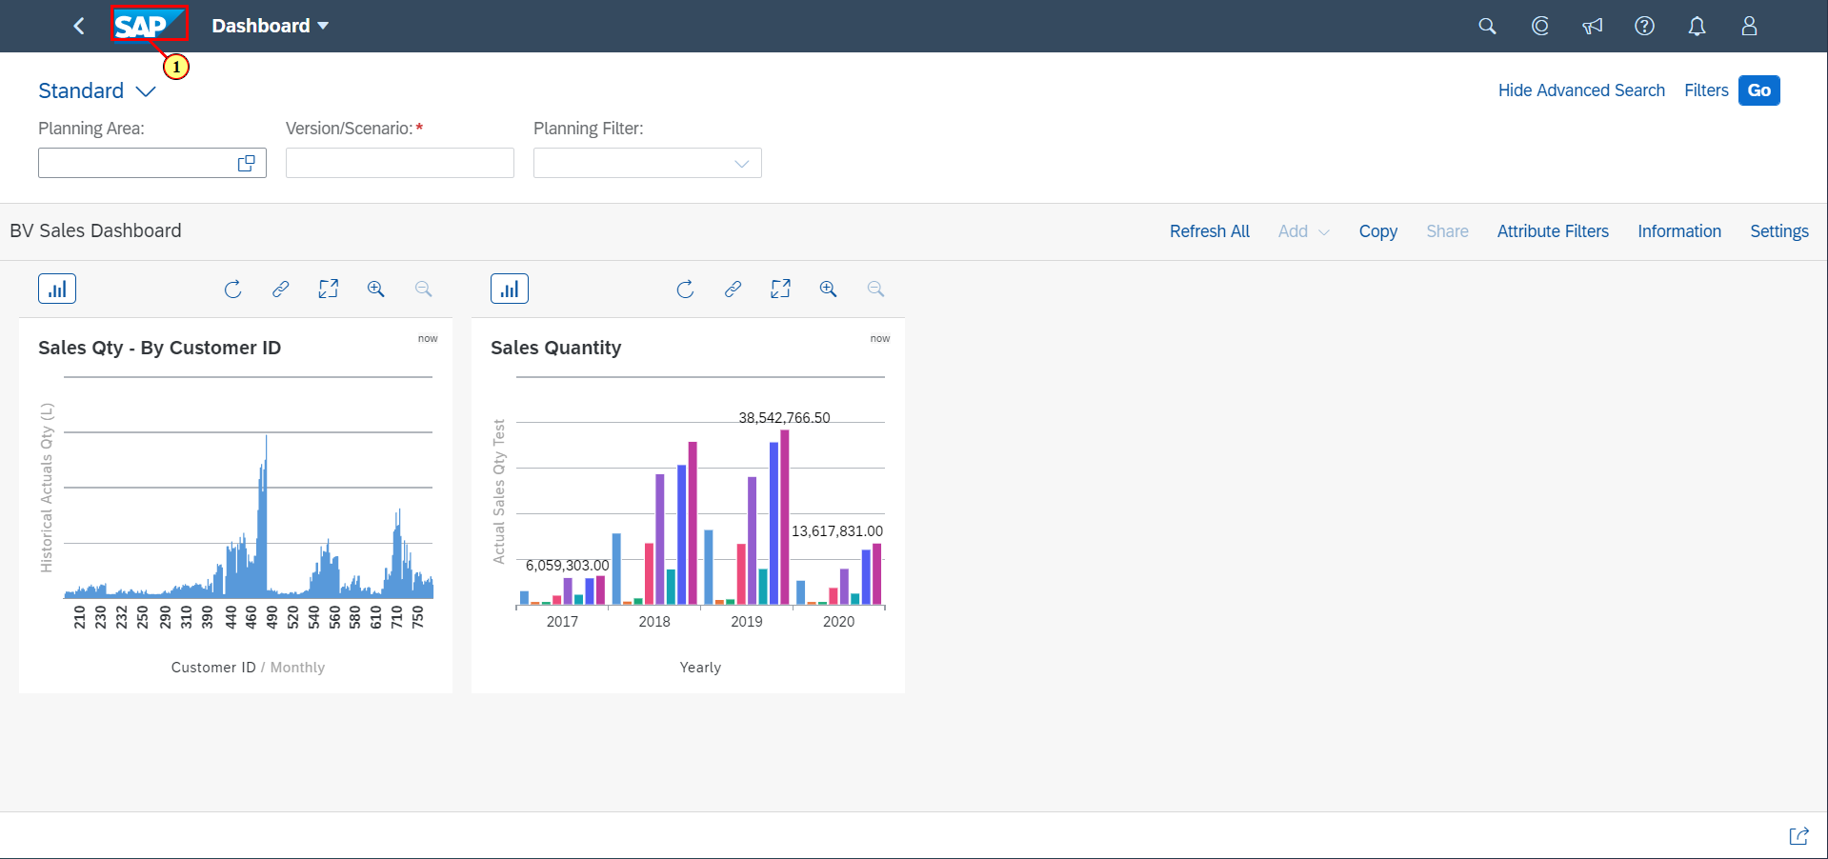

(1) Click on  **Home Page**

Home - Google Chrome

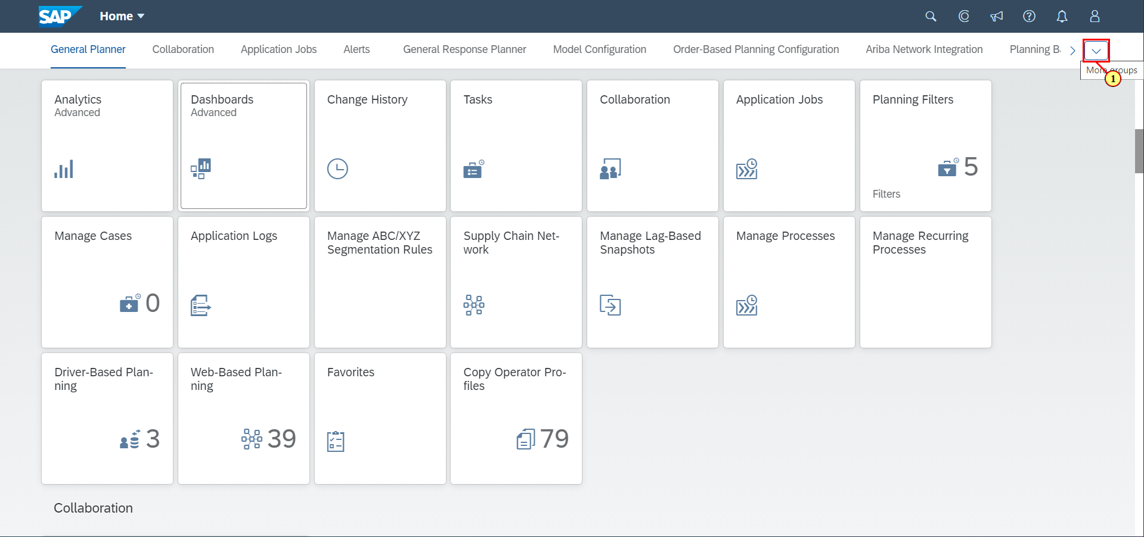

(1) Click on .



Home - Google Chrome

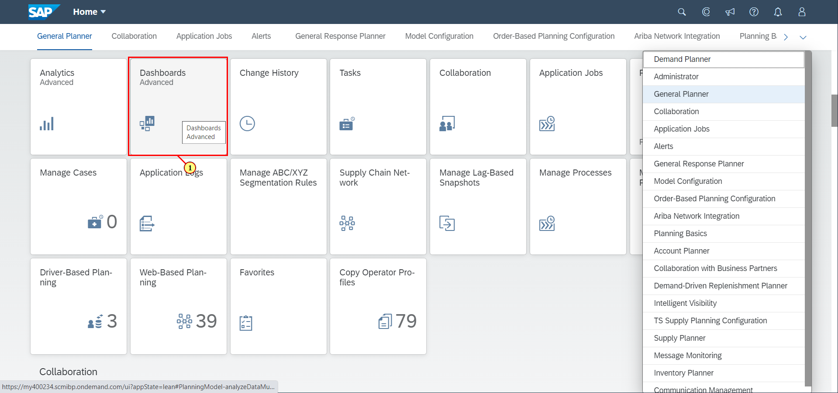

(1) Click on **Dashboards Advanced .**

Dashboard List - Google Chrome

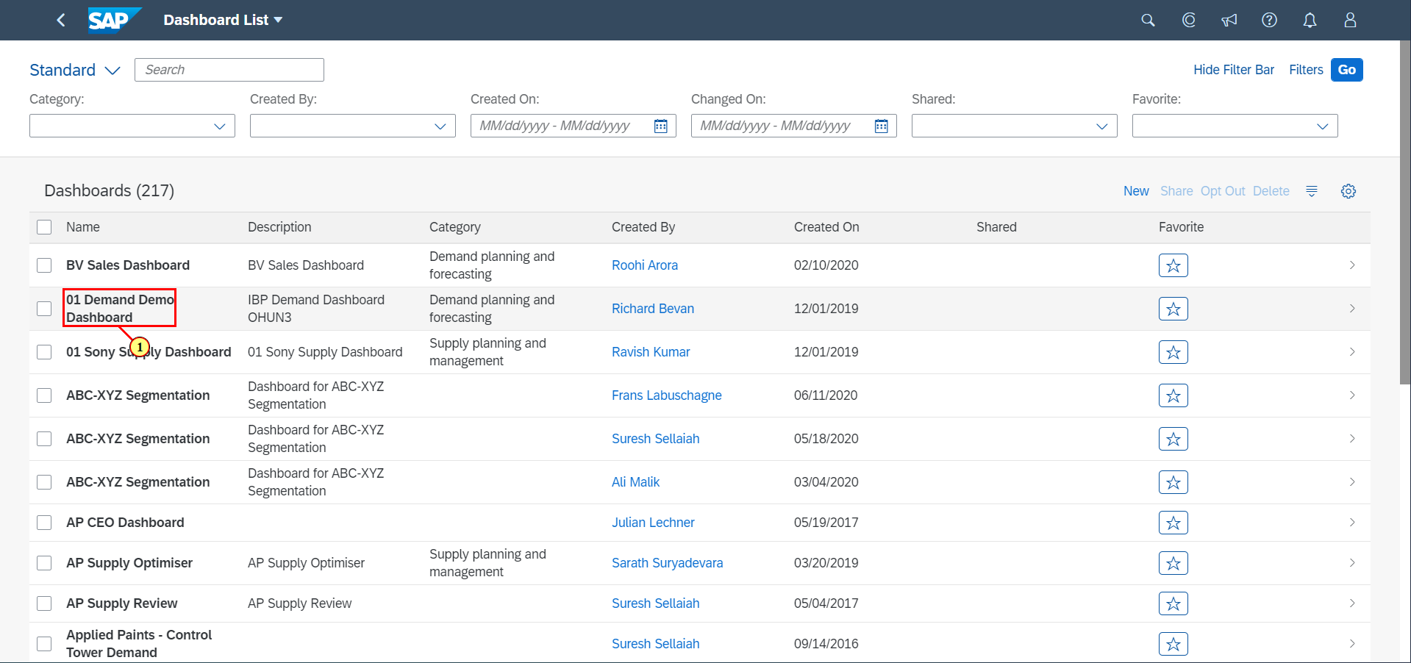

(1) Click on **01 Demand Demo Dashboard**.



Dashboard - Google Chrome

